CREATING A REPORT IN THE ELYNX APPLICATION

Overview

There are (3) elements of every report that you need to know (or at least have an idea about) before you start creating anything

- What device(s) will be in the report?
- What SCADALynx tag types from those devices?
  - Additionally, how should the data from these tag types be aggregated? (Hourly, Daily, Monthly, Yearly or not at all e.g ‘Raw’)
- For what duration will the report run?

Report Request Details
*Blue text are examples

- What device(s) will be in the report?

Many times, when creating a report, all the devices that you want in the final product are already in a group that you have defined in the eLynx application. There are a couple of things to keep in mind when creating a report configuration using a group as a source. One is that when you create your report you must start at point in the hierarchy that is equal to or above the level of the group hierarchy from which you are wanting devices.
For example, if you want a report that includes all the devices from the ‘Devices’ group, you must create the report configuration on that group or a parent group (e.g. ‘Acme Oil and Gas’ or ‘eLynx’ in this case)

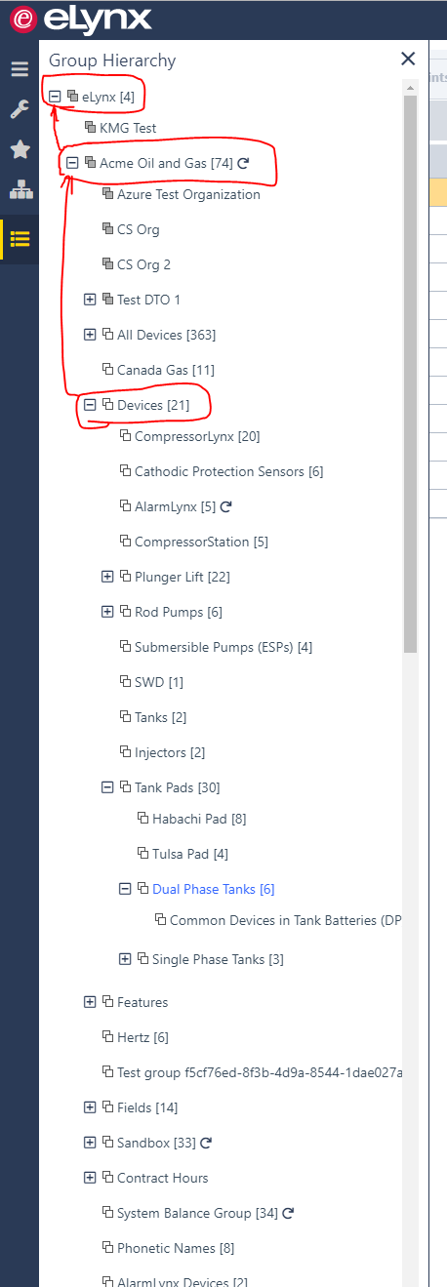

Another thing to consider when using a group is that the eLynx application supports dynamics groups. If your report is based on a dynamic group, the contents of the group (and therefore your report) can change based on whatever the criteria is to include devices. Of course, you also have the option of simply including only specific devices.

- CHECK POINT
What Devices and/or Groups do I want in the finished product?
  - All the devices in group A
  - Device1, Device2 & Device3
  - Device1, Device2, Device3 & all of the devices in group A

- What SCADALynx tag types from those devices?

Pressures? Temperatures? Flow rate? All the above? No problem! These are all examples of what we call ‘Tags’ in the eLynx application. Each tag has a ‘Tag Type’. Tag Types are what is used in the report configuration.
Here’s the difference. When you are looking at a ‘Device Details’ page you are looking at ‘tags’, which can have a name that differs from one device to the next.

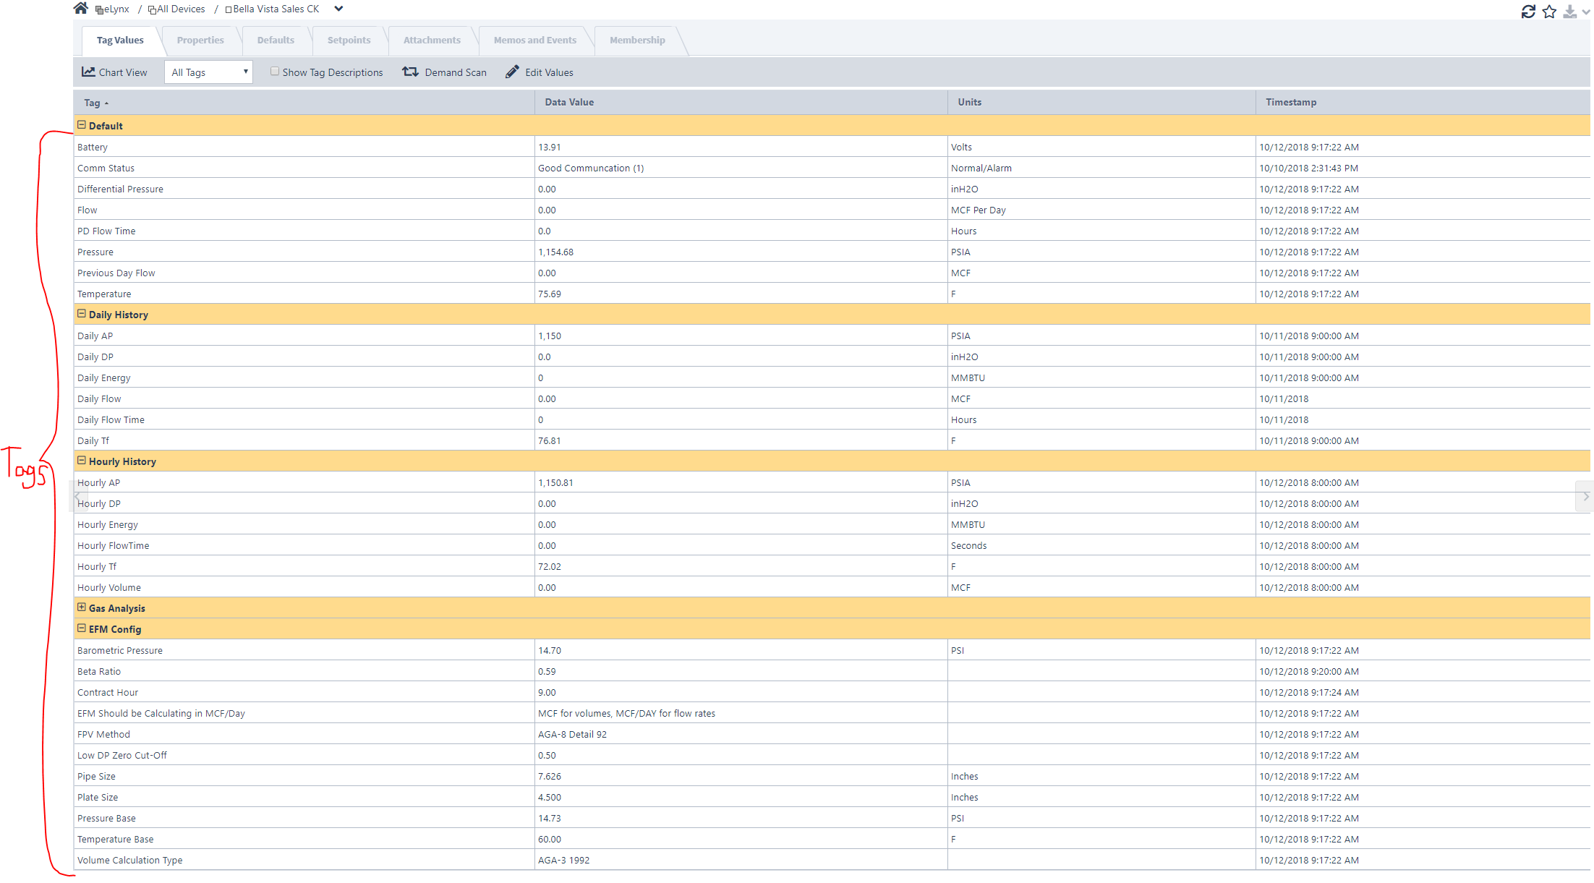

So, to see a tag’s “Tag Type” simply click on that tag and go to it’s ‘Properties’ tab. For example, lets find the Tag Type of the ‘Previous Day Flow’ tag in the ‘Default’ tag group. Simply click on the ‘Previous Day Flow’ tag and navigate to its properties tab:

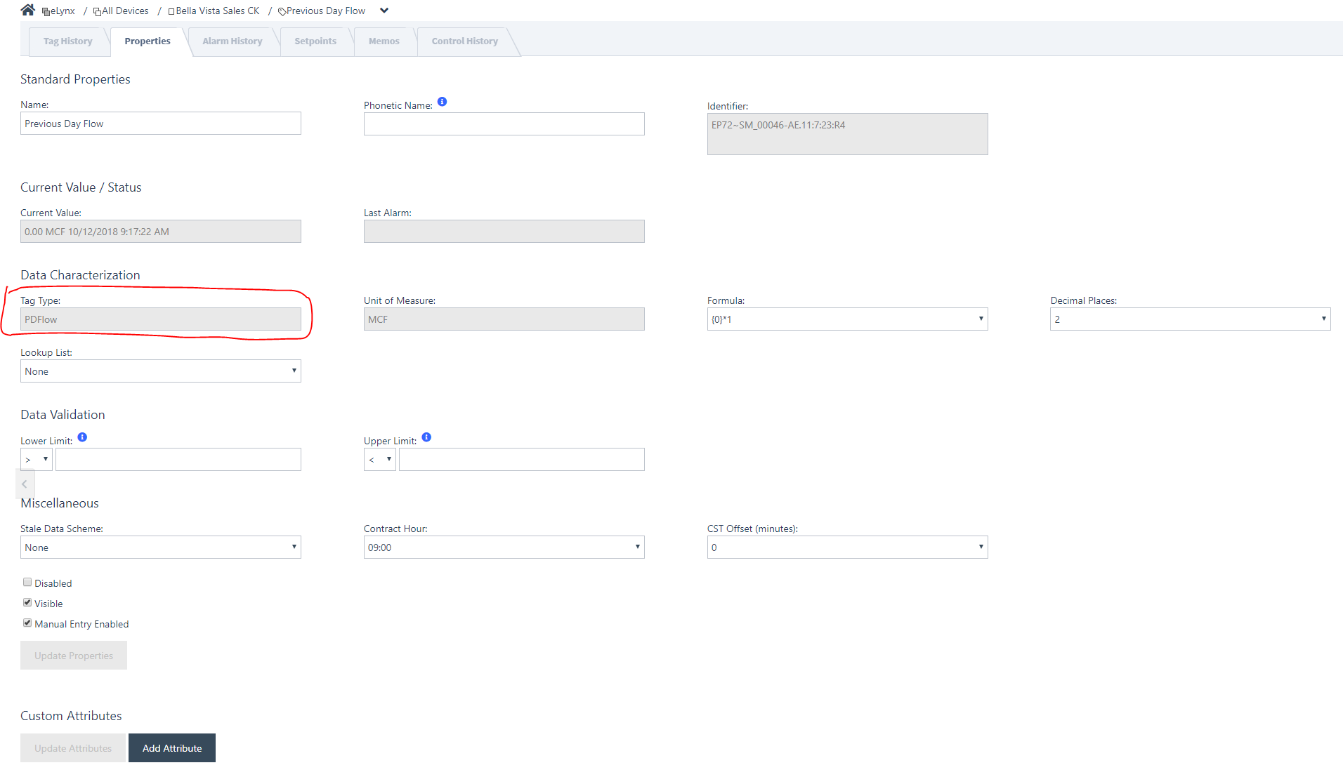

We can see above that the ‘Tag Type’ of the “Previous Day Flow” tag is “PDFlow”. Why is this important? Because when you are choosing ‘Data Values’ the report configuration the names are Tag Type names.

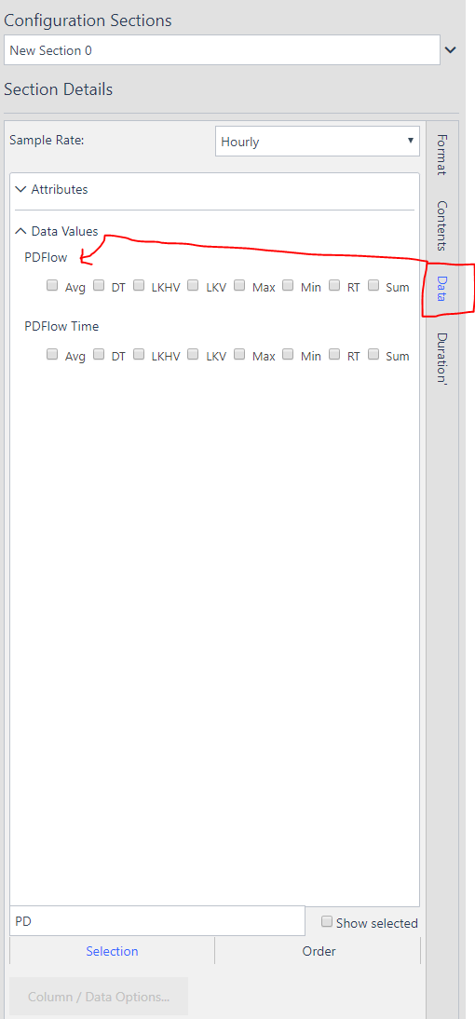

The fastest way to ensure you have all the data in the report that you want is to have two screens open. One with the report configuration and the other with the ‘Device Details’ page of a device that will be in your report. This will allow you to navigate between tags to quickly find the Tag Type name that you want in your report. You can then type the whole or partial Tag Type name in the search bar to find and include the data point.

*TIP – Sometimes devices have tags with the same/similar names, but the Tag Type of those tags is different. If you are seeing a device that is missing data in your report, double-check the Tag Type of the missing data point on that device.

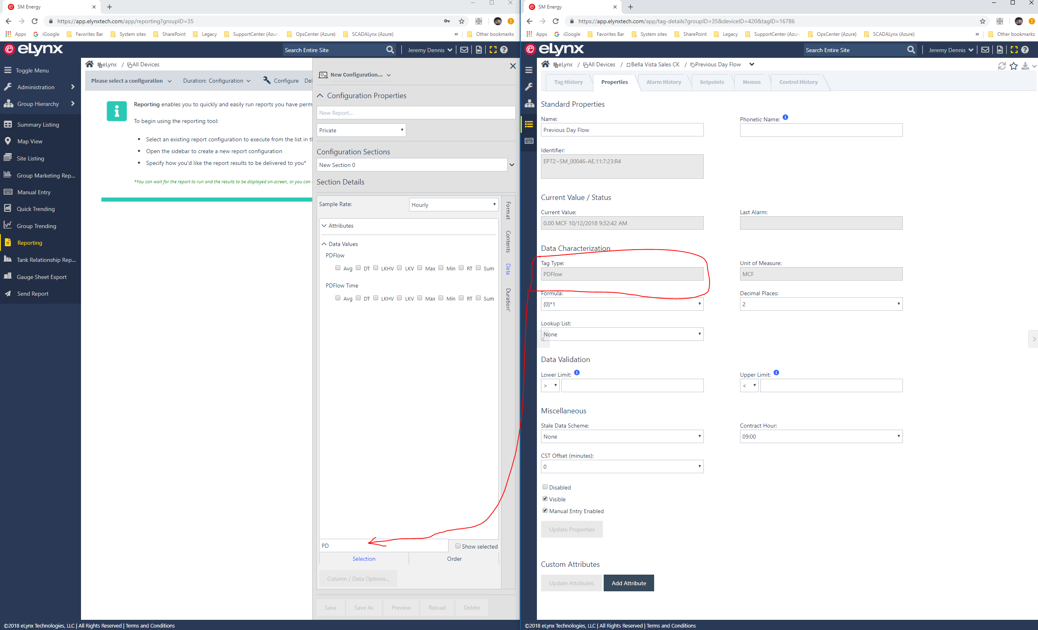

Hopefully the screenshots above evoked a couple of questions. What is a ‘Sample Rate’? And what are those check boxes under the Tag Type name?

SAMPLE RATE AND NUMERICAL FUNCTION

Are you wanting yesterday’s last known value? The average from previous hour? How about the total from current month? Sample Rate and Numerical Functions are how you set that up in the report configuration. The Sample Rate is how you want your Tag Types aggregated. The default is hourly, but you have options for Daily, Monthly, Yearly or Raw. For all but the ‘Raw’ Sample Rate, you’ll have to choose what Numerical Function you want applied to the aggregated data in that Sample Rate. The options for the Numerical Function are Average, Last Known Historical Value, Last Known Value, Max, Min and Sum. The difference between LKV and LKHV is explained below.
When you choose a ‘Raw’ Sample Rate there is no numerical function to apply, because there is no aggregation of the data. You are getting the ‘Raw’ data.

- CHECK POINT
What Tag Types do I want in the report?
  - Flow – Gas Daily Accumulated Total
  - Differential Pressure
  - Plate Size
  - Tank Level

How do I want the data aggregated?
  - Raw (no aggregation)
  - Hourly
  - Daily
  - Monthly
  - Yearly

What Numerical Function do I want applied over that aggregated data?
  - Last Known Value
    - The last known value of the sample rate you choose
    - If Daily sample rate is chosen, LKV returns the data with the last timestamp of the production day
    - If no value with a timestamp in the production day is present, no value is returned
  - Last Known Historical Value
    - Last known historical value for the tag
    - If no value is present in the sample rate the last value recorded is what is returned
    - EVEN if that value is outside the timeframe the report is setup for
  - EXAMPLE:
    - I setup a report with Daily Sample Rate on the Tag Types and Last Known Value. The Duration is ‘Current Single Timeframe: Day’, which means I want the last known value of my Tag Types in the current day. If there is no value for my Tag Types in the current production day, then no data will be returned for that device. If I were to have use Last Known Historical Value on my Tag Types and there were no data in the current production day, the report would go back to the previous production days to find a value.
  - Average
    - The average value for the tag type in the hour, day, month or year
  - Max
    - The maximum value for the tag type in the hour, day, month or year
  - Min
    - The minimum value for the tag type in the hour, day, month or year
  - Sum
    - The sum of the values for a tag type in the hour, day, month or year

- For what duration will the report run?

The hard part is done! Now that you have the devices, Tag Types, Sample Rate and Numerical Function to apply over that Sample Rate defined in the report all that is left is to choose the ‘Duration’ for which the report will run. There are currently (4) options for the report Duration.

- Report Duration
  - Multiple Timeframes
    - Configure the report to run for __ [Hours, Days, Months, Years] starting __ [Hours, Days, Months, Years] ago.
    - If you want the report to run for the previous 7 days and include today, then you would set up Multiple Timeframes as:
      - Run for 8 Days
      - Starting 7 Days ago
  - Current Single Timeframe
    - Configure the report to run for the current [Hour, Day, Month, Year]
  - Previous Single Timeframe
    - Configure the report to run for the previous [Hour, Day, Month, Year]
  - Specific Start and End Times
    - Configure the report to run from: ‘1/1/2018’ to: ‘1/30/2018’

ADDITIONAL REPORT CONFIGURATION OPTIONS

If you need your report formatted a special way, there are options in the configuration editor to allow you to pivot the data a couple of different ways. We can also always do some custom report work for you to get the data looking exactly like what you want. Here are the available report styles and some examples of what they look like.

- Report style: 1, 2, 3 or Custom
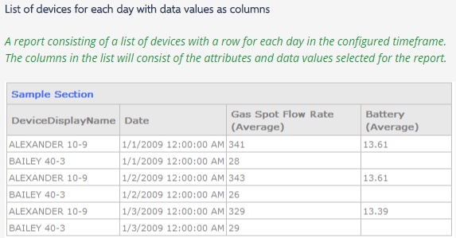
Figure 1. Report style 1 can use Raw, Hourly, Daily, Monthly or Yearly aggregation.
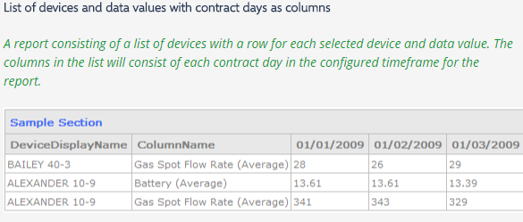
Figure 2. Report style 2 can ONLY use Daily aggregation
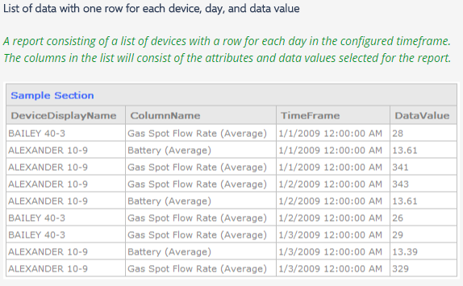
Figure 3. Report style 3 can use Raw, Hourly, Daily, Monthly or Yearly aggregation

On the same page that you find the report style selector you’ll also see these options:

- Use effective date
  - Honor the effective date offset configured for the tag type(s) in the report
  - This is normally used to associate a ‘previous day’ value with production day it occurred
- Include devices with no data
- Include days with no data
- Include a final row with totals

Finally, you have the ability to include metadata from the devices in your report. This is done through the ‘Attributes’ drop down on the ‘Data’ page of the configuration editor (e.g. the same page where you choose your Tag Types). There’s no limit to the kinds of metadata that you can include. The only caveat is that it must be on the device as a custom attribute. Some examples are:

SCADALynx Attributes
  - Device Name
  - Date
  - SCADALynx DeviceID.
  - API #
  - External ID (ID that associates the device with your backend system (e.g. ProCount, Merrick, Field Direct, Aries, etc))

